**GUIA BÁSICA SQL**

1. **CREATE TABLA (CREATE TABLE)**

CREATE TABLE nom_table (id INTEGER PRIMARY KEY, col1_name TYPE, col2_name TYPE, ...., coln_name TYPE);

- It is better start with an id as **PRIMARY KEY**.

- Most frequently **TYPE** are: **TEXT** , **INTEGER** (number without decimals), **REAL** and **BLOB** (keep the input format).

**EXAMPLE:**

CREATE TABLE groceries (id INTEGER PRIMARY KEY, name TEXT, quantity INTEGER );

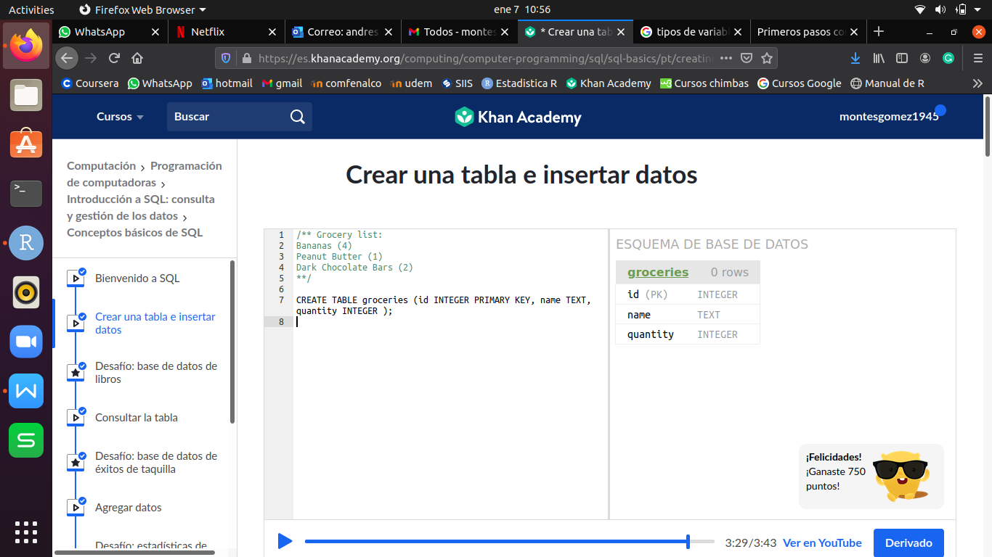

1. **INSERT VALUES IN A TABLE (INSERT INTO)**

INSERT INTO nom_table VALUES (‘text’, 5, 2,7, ....);

- For each line, we have to make an INSERT.

- Text between quotation marks and can be double (“ ”) o simple (‘ ’), SQL accept both.

**EXAMPLE:**

INSERT INTO groceries VALUES (1, "Bananas", 4);

INSERT INTO groceries VALUES (2, "Peanut Butter", 1);

INSERT INTO groceries VALUES (3, "Dark chocolate bars", 2);

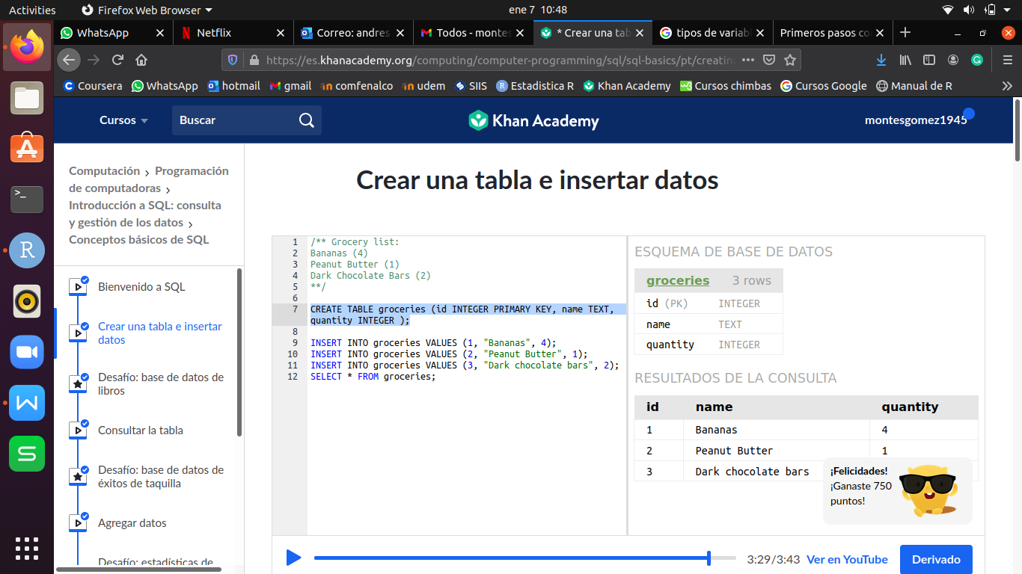

1. **VIEW TABLE (SELECT)**

SELECT * FROM nom_table;

**EXAMPLE:**

SELECT * FROM groceries;

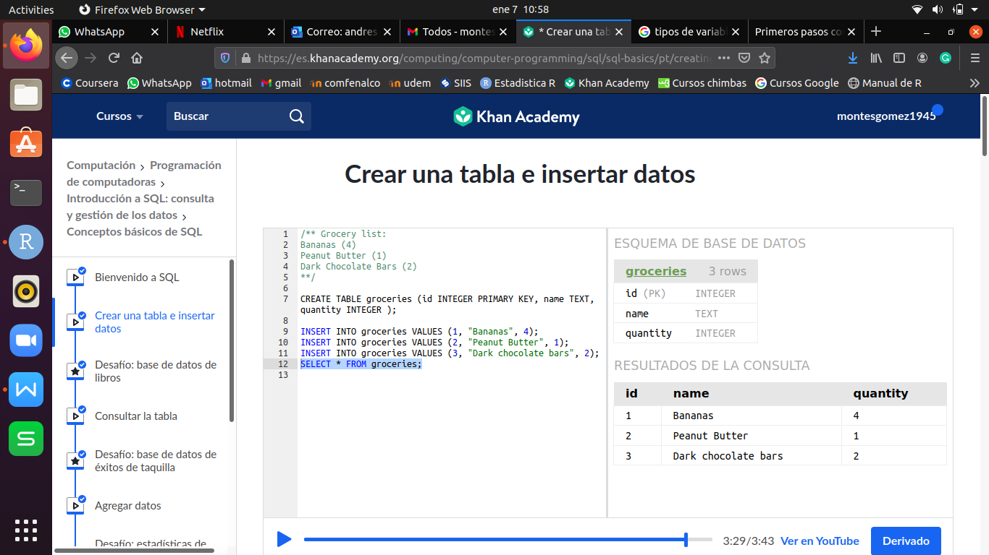

1. **VIEW A COLUMN**

SELECT nom_col FROM nom_table;

**EXAMPLE:**

SELECT name FROM groceries;

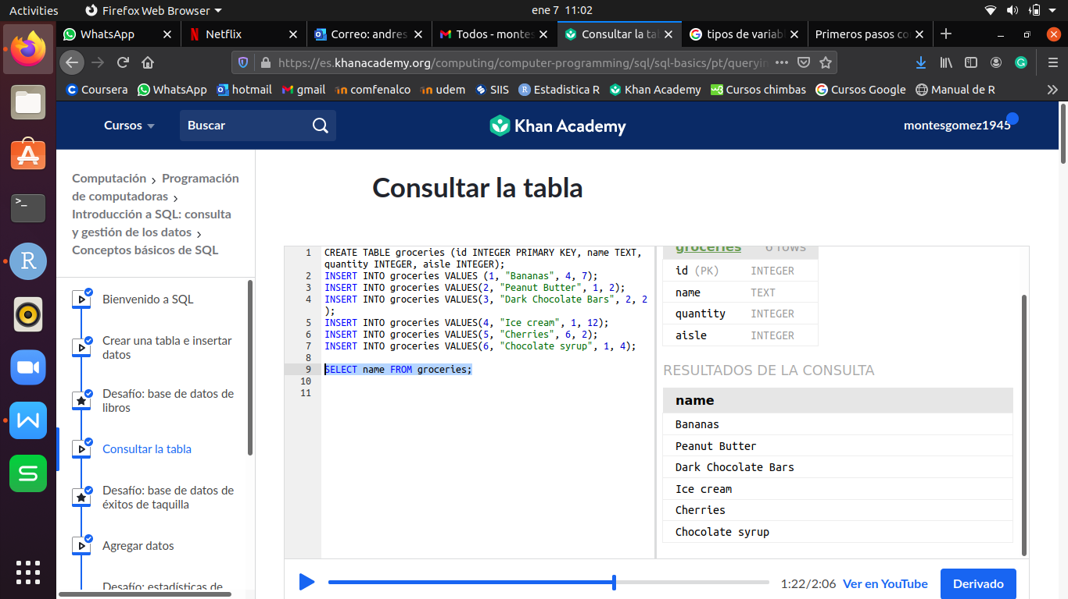

1. **ARRANGE TABLE ACCORDING TO A COLUMN (ORDER BY)**

SELECT * FROM nom_table ORDER BY nom_col DESC ó ASC;

**EXAMPLE:**

SELECT * FROM groceries ORDER BY quantity;

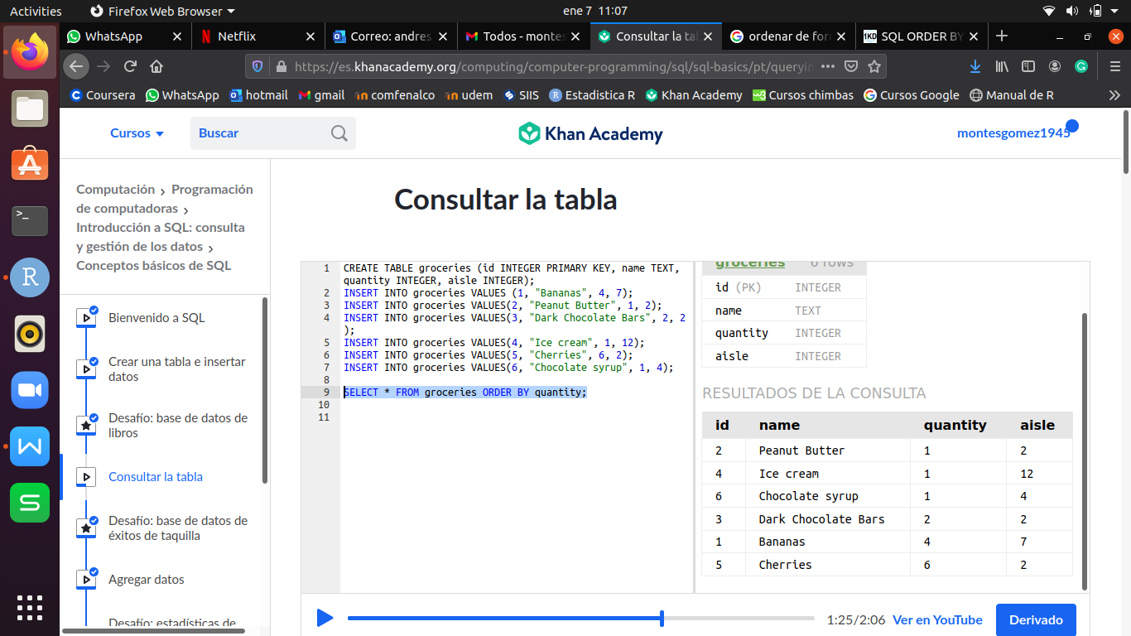

- By default SQL arrange ascending, if we want to order descendingly we have to add a **DESC** at the end.

**EXAMPLE:**

SELECT * FROM groceries ORDER BY quantity DESC;

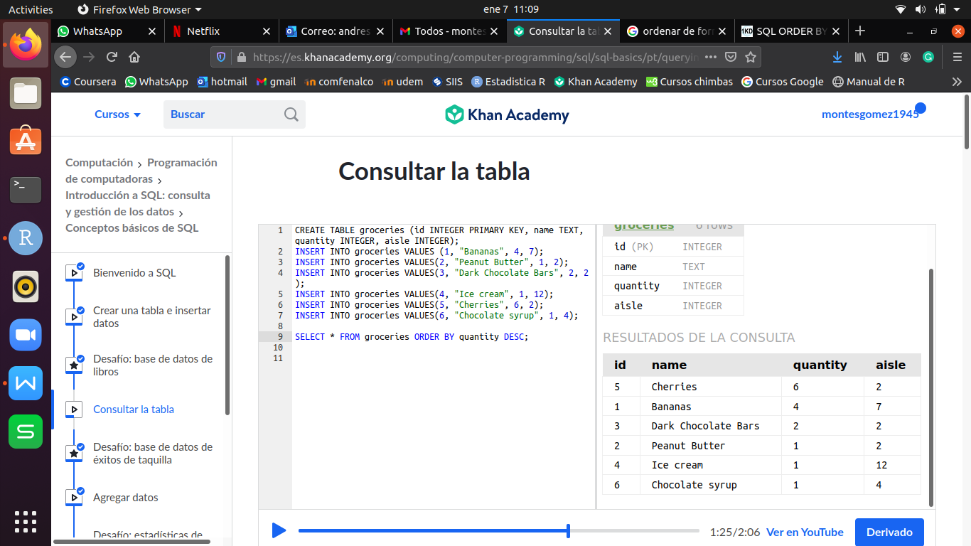

1. **FILTER (WHERE)**

... WHERE operador 5, 3.2, ‘text’, ....

- Operador could be >, <, =, >=, <=, ...

- ORDER BY always at the end.

**EXAMPLE:**

SELECT * FROM groceries WHERE quantity > 3 ORDER BY name;

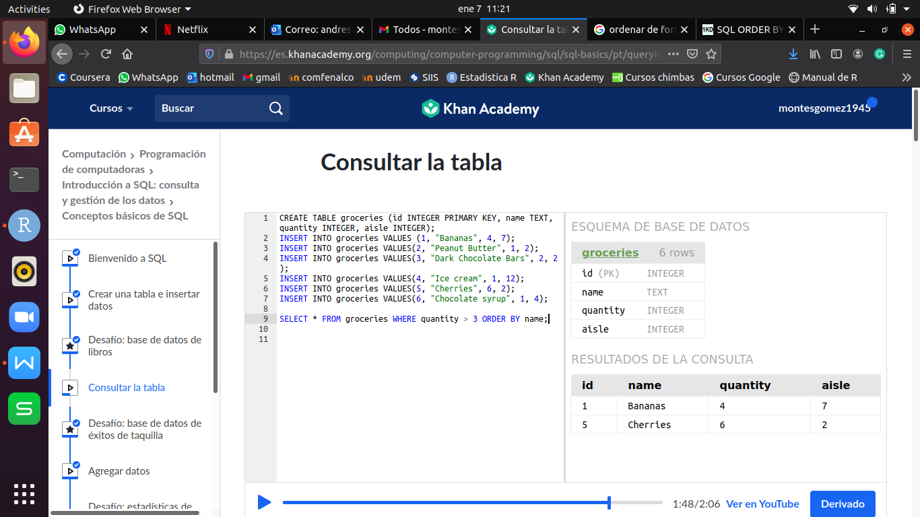

- It is possible apply filter with most of one condition adding **OR, AND.**

**EXAMPLE:**

CREATE TABLE exercise_logs (id INTEGER PRIMARY KEY AUTOINCREMENT, type TEXT, minutes INTEGER, calories INTEGER, heart_rate INTEGER);

INSERT INTO exercise_logs(type, minutes, calories, heart_rate) VALUES ("biking", 30, 100, 110);

INSERT INTO exercise_logs(type, minutes, calories, heart_rate) VALUES ("biking", 10, 30, 105);

INSERT INTO exercise_logs(type, minutes, calories, heart_rate) VALUES ("dancing", 15, 200, 120);

SELECT * FROM exercise_logs WHERE calories > 50 AND minutes < 30;

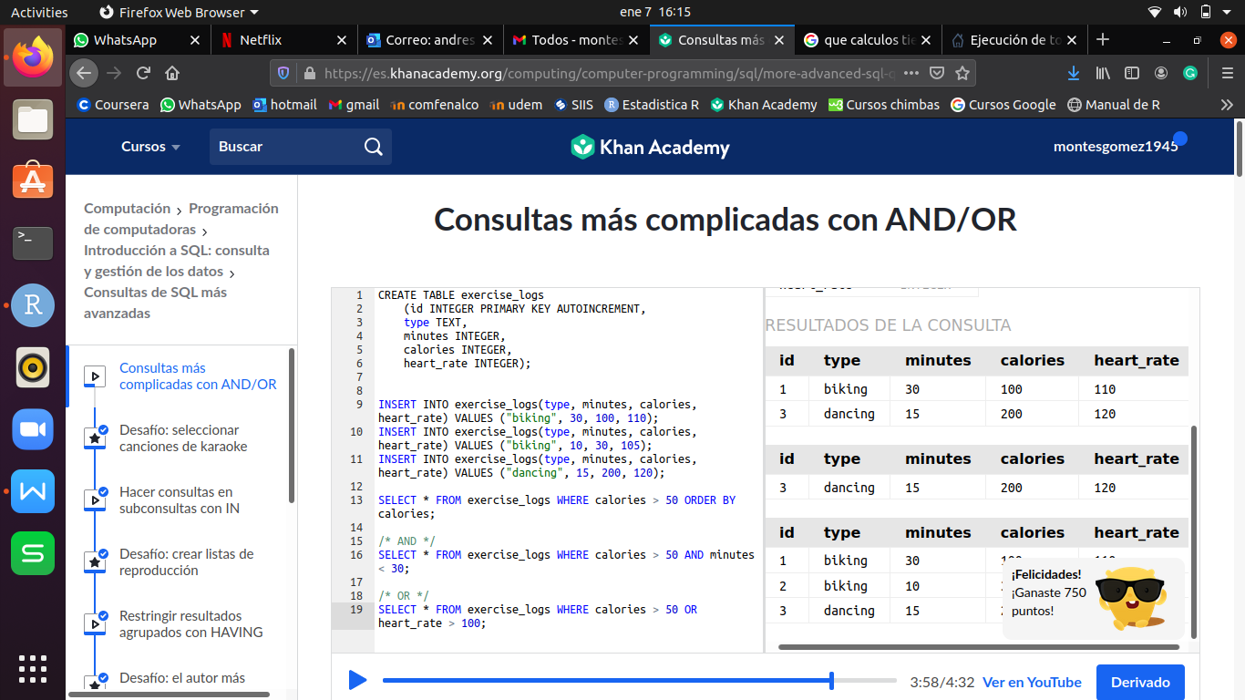

SELECT * FROM exercise_logs WHERE calories > 50 OR heart_rate > 100;

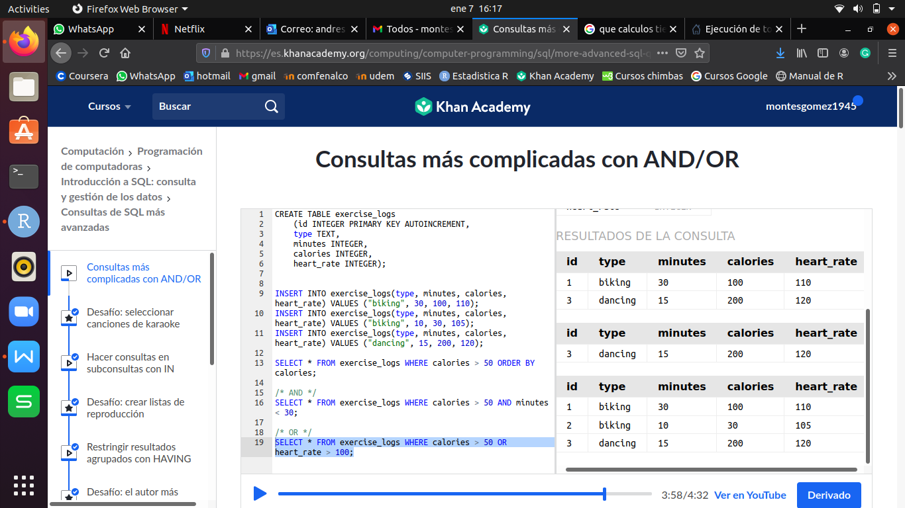

1. **FUNCTIONS**

SELECT FUNCTION(nom_col) FROM nom_table;

- **FUNCTION** can be **SUM**, **AVG**(Mean), **MAX, MIN**.

INSERT INTO groceries VALUES (1, "Bananas", 56, 7);

INSERT INTO groceries VALUES(2, "Peanut Butter", 1, 2);

INSERT INTO groceries VALUES(3, "Dark Chocolate Bars", 2, 2);

INSERT INTO groceries VALUES(4, "Ice cream", 1, 12);

INSERT INTO groceries VALUES(5, "Cherries", 6, 2);

INSERT INTO groceries VALUES(6, "Chocolate syrup", 1, 4);

**EXAMPLE:**

SELECT aisle, SUM(quantity) FROM groceries GROUP BY aisle;

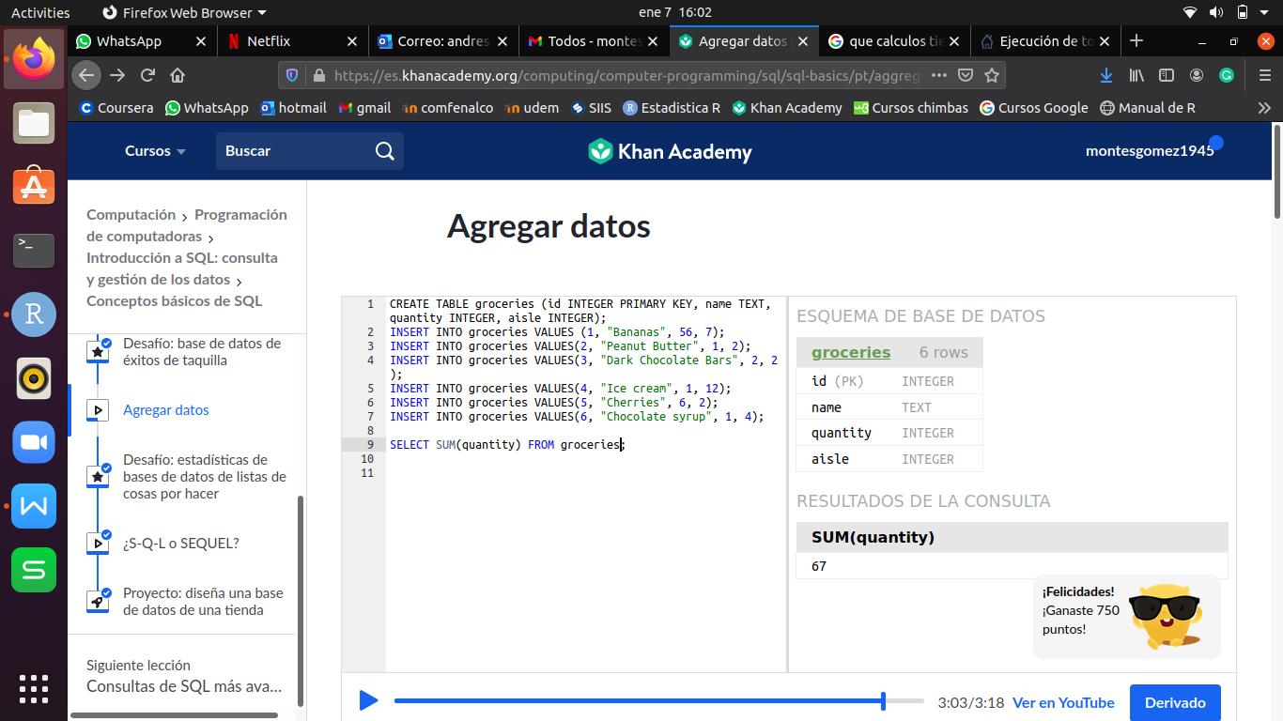

1. **OPERATIONS WITH FILTERS**

SELECT ***col_filter_name*** FUNCTION (nom_col_num) FROM nom_table GROUP BY ***col_filter_name;***

**EXAMPLE:**

SELECT **aisle**, SUM(quantity) FROM groceries GROUP BY **aisle**;

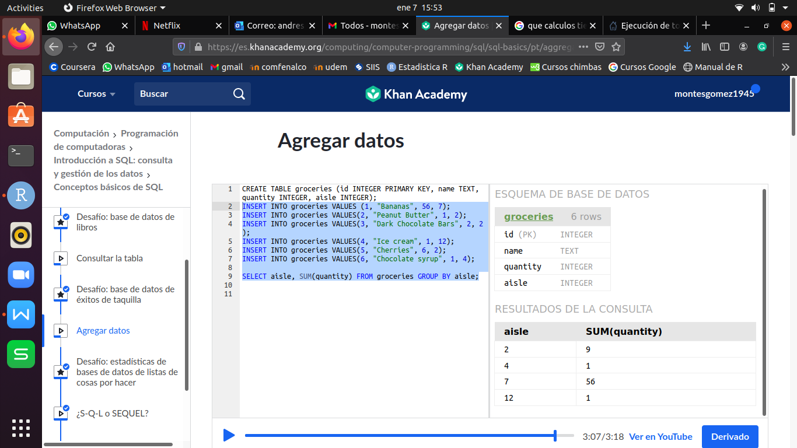

1. **MULTIPLE FILTERS - (IN, NOT IN)**

SELECT * FROM nom_table WHERE col_num_name IN (‘texto1’, ‘texto2’, ...);

**EXAMPLE:**

CREATE TABLE exercise_logs (id INTEGER PRIMARY KEY AUTOINCREMENT, type TEXT, minutes INTEGER, calories INTEGER, heart_rate INTEGER);

INSERT INTO exercise_logs(type, minutes, calories, heart_rate) VALUES ("biking", 30, 100, 110);

INSERT INTO exercise_logs(type, minutes, calories, heart_rate) VALUES ("biking", 10, 30, 105);

INSERT INTO exercise_logs(type, minutes, calories, heart_rate) VALUES ("dancing", 15, 200, 120);

INSERT INTO exercise_logs(type, minutes, calories, heart_rate) VALUES ("tree climbing", 30, 70, 90);

INSERT INTO exercise_logs(type, minutes, calories, heart_rate) VALUES ("tree climbing", 25, 72, 80);

INSERT INTO exercise_logs(type, minutes, calories, heart_rate) VALUES ("rowing", 30, 70, 90);

INSERT INTO exercise_logs(type, minutes, calories, heart_rate) VALUES ("hiking", 60, 80, 85);

SELECT * FROM exercise_logs WHERE type = "biking" OR type = "hiking" OR type = "tree climbing" OR type = "rowing";

SELECT * FROM exercise_logs WHERE type IN ("biking", "hiking", "tree climbing", "rowing");

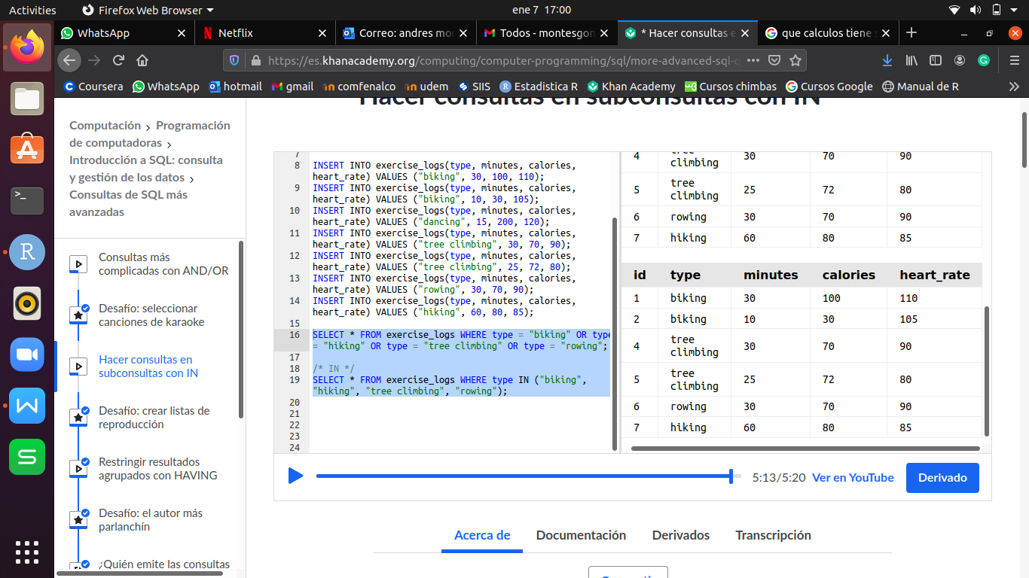

- **IN** is used to avoid multiple **OR** and make it easier for the user.

**EXAMPLE:**

CREATE TABLE drs_favorites (id INTEGER PRIMARY KEY, type TEXT, reason TEXT);

INSERT INTO drs_favorites(type, reason) VALUES ("biking", "Improves endurance and flexibility.");

INSERT INTO drs_favorites(type, reason) VALUES ("hiking", "Increases cardiovascular health.");

SELECT * FROM exercise_logs WHERE type IN (SELECT type FROM drs_favorites);

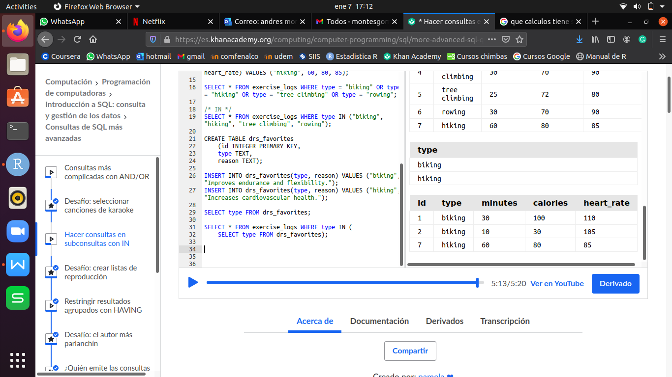

**EXAMPLE:**

SELECT * FROM exercise_logs WHERE type NOT IN (SELECT type FROM drs_favorites);

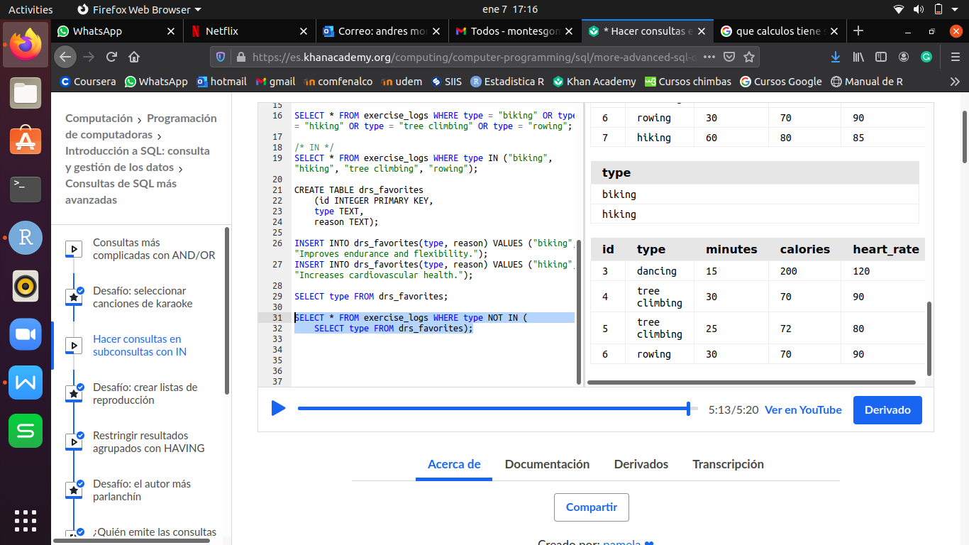

1. **QUERIES WITH DESIRED VALUE (LIKE)**

SELECT * FROM nom_table1 WHERE nom_col IN(SELECT nom_col FROM nom_table2 WHERE col_search_name LIKE ‘%valor_bucado%);

- The secound part of **SELECT** is an other related table by nom_col.

- Before **IN** goes the wanted filter.

**EXAMPLE:**

SELECT * FROM exercise_logs WHERE type IN (SELECT type FROM drs_favorites WHERE reason LIKE "%cardiovascular%");

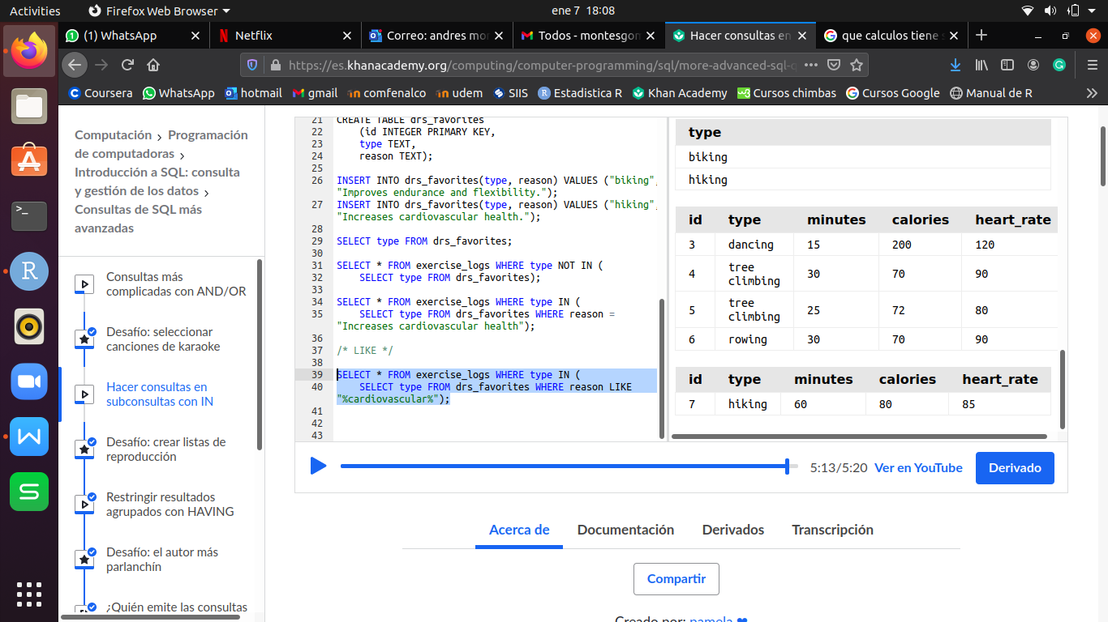

1. **MAKE A FILTER TO AN OPERATION (HAVING)**

SELECT nom_col FUNCION(nom_col_num) AS nom_col_resul FROM nom_tabla GROUP BY nom_col HAVING nom_result;

**EXAMPLE:**

SELECT type, SUM(calories) AS total_calories FROM exercise_logs

GROUP BY type HAVING total_calories > 150

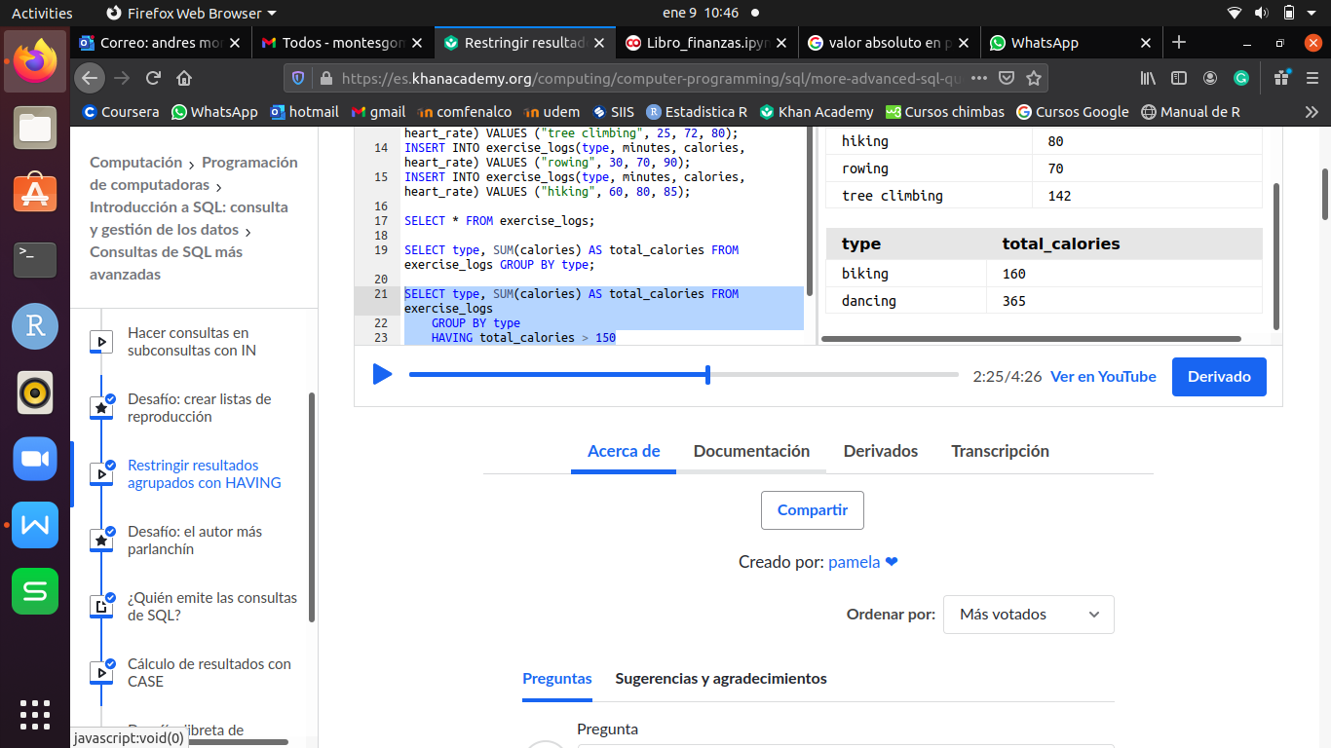

1. **CASE**

SELECT OPERATION(*)

CASE

WHEN name_col_num **operador** # or operation THEN ‘text 1’

WHEN name_col_num **operador** # or operation THEN ‘text 2’ ...

ELSE ‘text if donesn’t fulfill the conditions’

END AS ‘col_search_name’

FROM nom_table GROUP BY col_search_name;

- **CASE** is like a **SWITCH**.

- **CASE** create a new column ‘col_search_name’ accordin to given ranges (**WHERE; ELSE**). Wuth this new column is easier to do the searching.

**EXAMPLE:**

SELECT COUNT(*),

CASE

WHEN heart_rate > 220-30 THEN "above max"

WHEN heart_rate > ROUND(0.90 * (220-30)) THEN "above target"

WHEN heart_rate > ROUND(0.50 * (220-30)) THEN "within target"

ELSE "below target"

END as "hr_zone"

FROM exercise_logs

GROUP BY hr_zone;

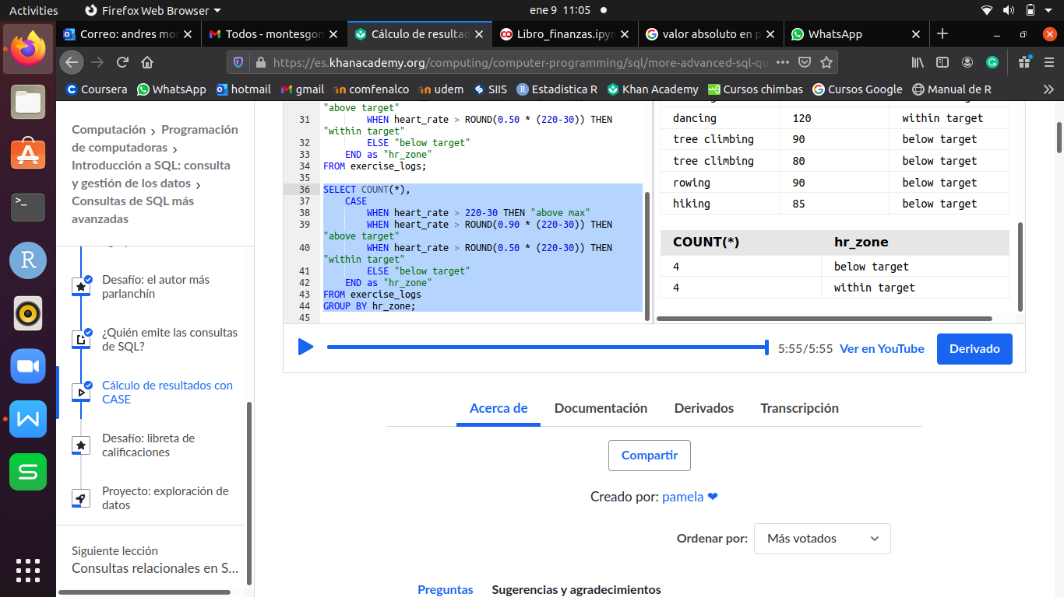

1. **EXPLICIT INNER JOIN**

SELECT nom_table.nom_col1, nom_table.nom_col2, ... FROM table1

JOIN table2 ON table1.id(PK) = table2.col_id;

- It is very important input at the beginning of the table (nom_table) where we are going to take the column (nom_col), because it is possible that other tables has columns with the same name.

**EXAMPLE:**

CREATE TABLE students (id INTEGER PRIMARY KEY, first_name TEXT, last_name TEXT, email TEXT, phone TEXT, birthdate TEXT);

INSERT INTO students (first_name, last_name, email, phone, birthdate)

VALUES ("Peter", "Rabbit", "peter@rabbit.com", "555-6666", "2002-06-24");

INSERT INTO students (first_name, last_name, email, phone, birthdate)

VALUES ("Alice", "Wonderland", "alice@wonderland.com", "555-4444", "2002-07-04");

CREATE TABLE student_grades (id INTEGER PRIMARY KEY, student_id INTEGER, test TEXT, grade INTEGER);

INSERT INTO student_grades (student_id, test, grade) VALUES (1, "Nutrition", 95);

INSERT INTO student_grades (student_id, test, grade) VALUES (2, "Nutrition", 92);

INSERT INTO student_grades (student_id, test, grade) VALUES (1, "Chemistry", 85);

INSERT INTO student_grades (student_id, test, grade) VALUES (2, "Chemistry", 95);

SELECT students.first_name, students.last_name, students.email, student_grades.test, student_grades.grade FROM students

JOIN student_grades ON students.id = student_grades.student_id

WHERE grade > 90;

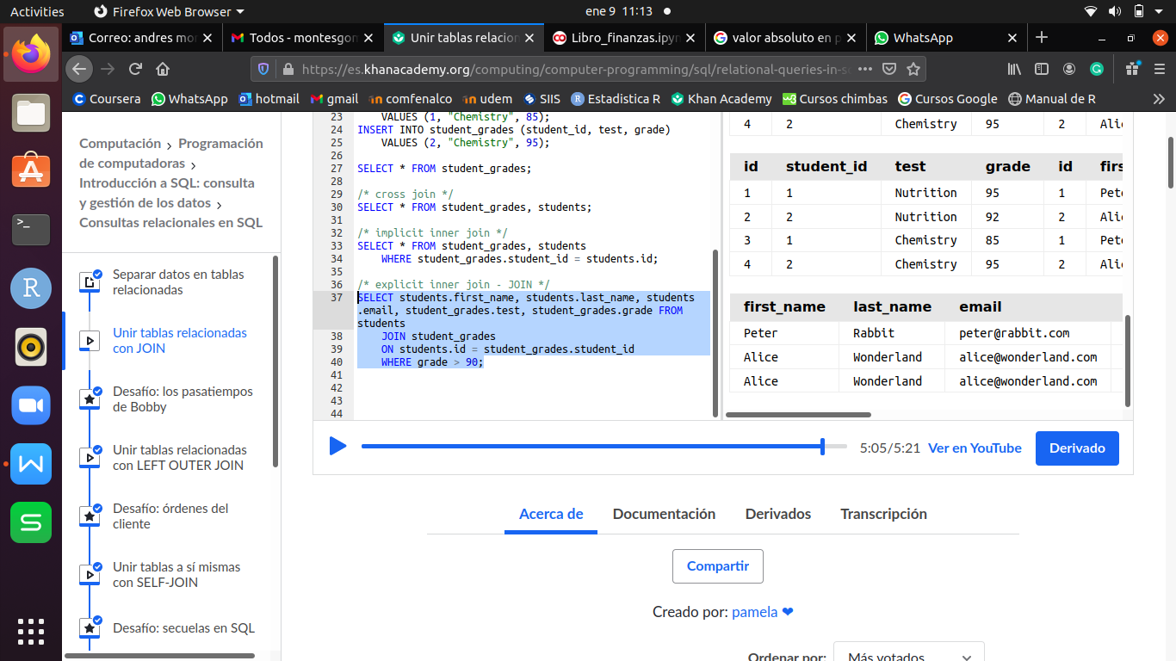

1. **LEFT OUTER JOIN**

SELECT nom_col1, nom_col2, ... FROM tabla1 LEFT OUTER JOIN tabla2

ON tabla1.id(PK) = tabla2.col_id;

- **LEFT OUTER JOIN** is used to when we want to show all the values of the columns selected, inclusive this hasn’t registers in the other table.

**EXAMPLE:**

CREATE TABLE student_projects (id INTEGER PRIMARY KEY, student_id INTEGER, title TEXT);

INSERT INTO student_projects (student_id, title) VALUES (1, "Carrotapault");

SELECT students.first_name, students.last_name, student_projects.title FROM students LEFT OUTER JOIN student_projects

ON students.id = student_projects.student_id;

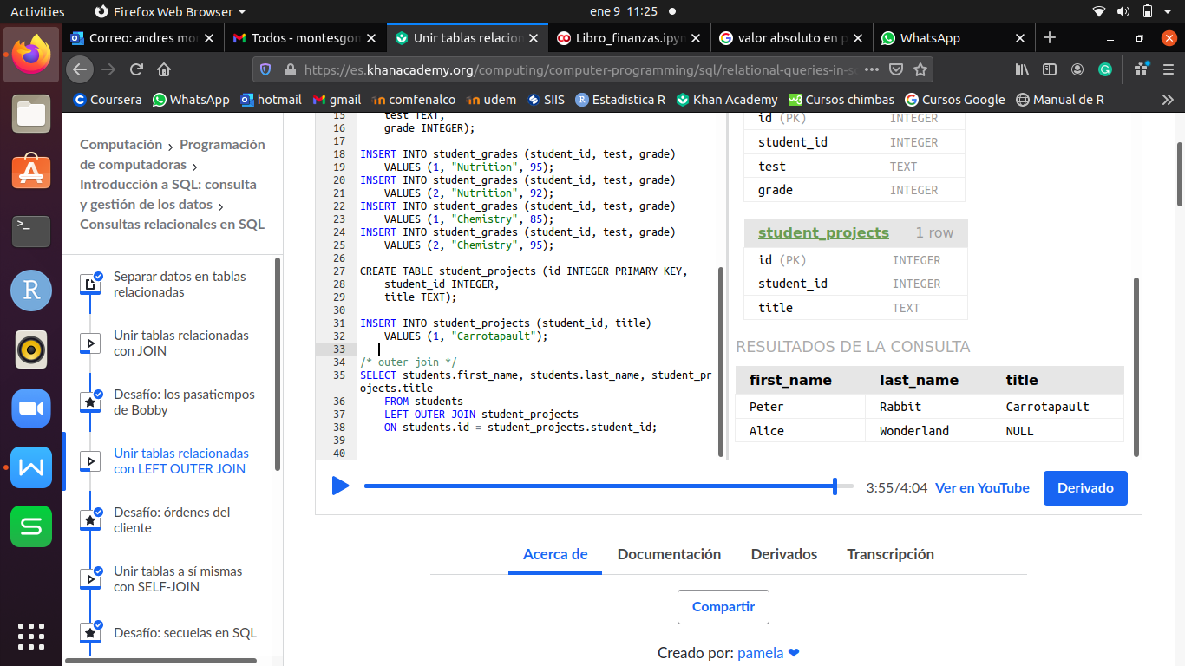

1. **SELF JOIN**

SELECT nom_col1, nom_col2, ..., alias.nom_col AS nom_com_wanted FROM table JOIN table alias

ON table.col_id = alias.id(PK);

- Used to link columns from the same table.

**EXAMPLE:**

CREATE TABLE students (id INTEGER PRIMARY KEY AUTOINCREMENT, first_name TEXT, last_name TEXT, email TEXT, phone TEXT, birthdate TEXT,

buddy_id INTEGER);

INSERT INTO students VALUES (1, "Peter", "Rabbit", "peter@rabbit.com", "555-6666", "2002-06-24", 2);

INSERT INTO students VALUES (2, "Alice", "Wonderland", "alice@wonderland.com", "555-4444", "2002-07-04", 1);

INSERT INTO students VALUES (3, "Aladdin", "Lampland", "aladdin@lampland.com", "555-3333", "2001-05-10", 4);

INSERT INTO students VALUES (4, "Simba", "Kingston", "simba@kingston.com", "555-1111", "2001-12-24", 3);

SELECT students.first_name, students.last_name, buddies.email as buddy_email FROM students JOIN students buddies

ON students.buddy_id = buddies.id;

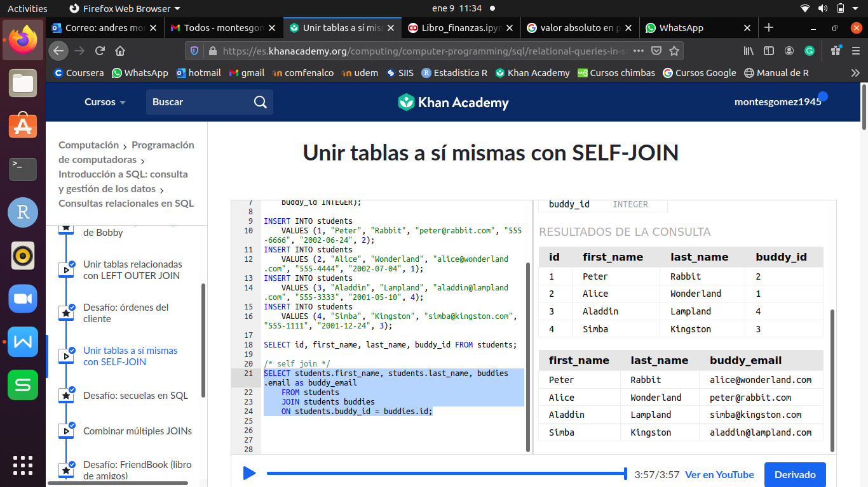

1. **MULTIPLE JOIN**

SELECT a.nom_col, b.nom_col FROM table2

JOIN table1 a ON tabla2.col_id = a.id(PK)

JOIN table1 b ON tabla2.col_id = b.id(PK)

**EXAMPLE:**

CREATE TABLE students (id INTEGER PRIMARY KEY, first_name TEXT, last_name TEXT, email TEXT, phone TEXT, birthdate TEXT);

INSERT INTO students (first_name, last_name, email, phone, birthdate)

VALUES ("Peter", "Rabbit", "peter@rabbit.com", "555-6666", "2002-06-24");

INSERT INTO students (first_name, last_name, email, phone, birthdate)

VALUES ("Alice", "Wonderland", "alice@wonderland.com", "555-4444", "2002-07-04");

INSERT INTO students (first_name, last_name, email, phone, birthdate)

VALUES ("Aladdin", "Lampland", "aladdin@lampland.com", "555-3333", "2001-05-10");

INSERT INTO students (first_name, last_name, email, phone, birthdate)

VALUES ("Simba", "Kingston", "simba@kingston.com", "555-1111", "2001-12-24");

CREATE TABLE student_projects (id INTEGER PRIMARY KEY, student_id INTEGER, title TEXT);

INSERT INTO student_projects (student_id, title) VALUES (1, "Carrotapault");

INSERT INTO student_projects (student_id, title) VALUES (2, "Mad Hattery");

INSERT INTO student_projects (student_id, title) VALUES (3, "Carpet Physics");

INSERT INTO student_projects (student_id, title) VALUES (4, "Hyena Habitats");

CREATE TABLE project_pairs (id INTEGER PRIMARY KEY, project1_id INTEGER, project2_id INTEGER);

INSERT INTO project_pairs (project1_id, project2_id) VALUES(1, 2);

INSERT INTO project_pairs (project1_id, project2_id) VALUES(3, 4);

SELECT a.title, b.title FROM project_pairs

JOIN student_projects a ON project_pairs.project1_id = a.id

JOIN student_projects b ON project_pairs.project2_id = b.id;

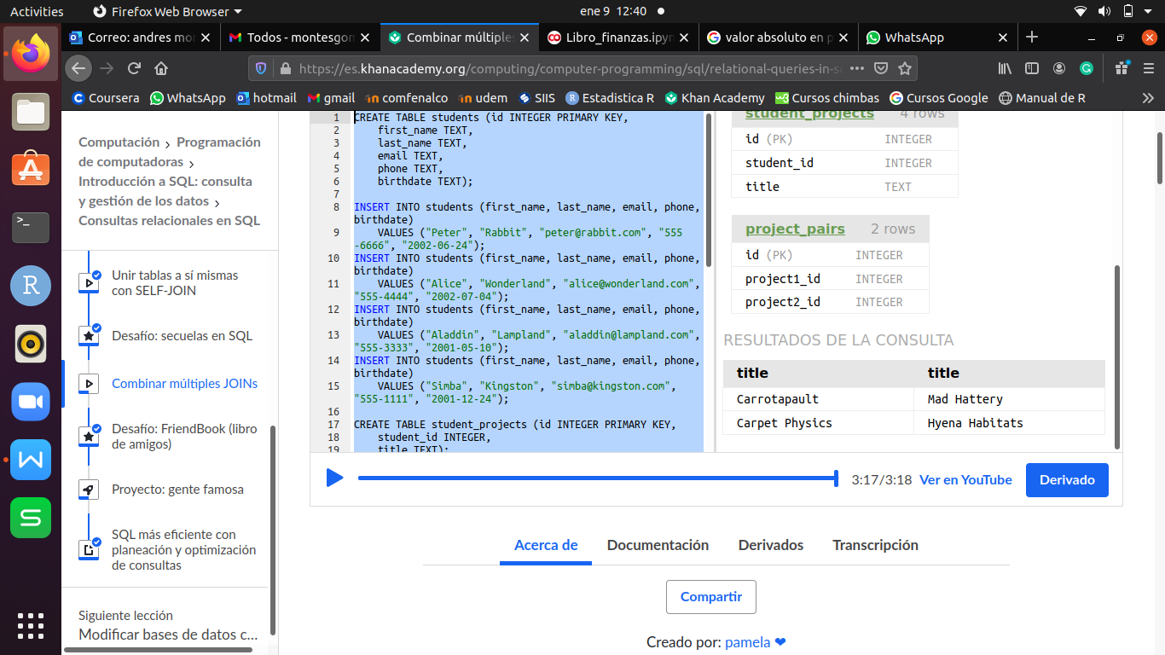

1. **UPDATE**

UPDATE table SET nom_col = ‘wath I want to update’ WHERE nom.colx = # ó ‘char’ AND nom_coly = # ó ‘char’ o simply the id(PK) if I know it.

**EXAMPLE:**

CREATE TABLE users (id INTEGER PRIMARY KEY, name TEXT);

CREATE TABLE diary_logs (id INTEGER PRIMARY KEY, user_id INTEGER, date TEXT, content TEXT);

INSERT INTO diary_logs (user_id, date, content) VALUES (1, "2015-04-01",

"I had a horrible fight with OhNoesGuy and I buried my woes in 3 pounds of dark chocolate.");

INSERT INTO diary_logs (user_id, date, content) VALUES (1, "2015-04-02",

"We made up and now we're best friends forever and we celebrated with a tub of ice cream.");

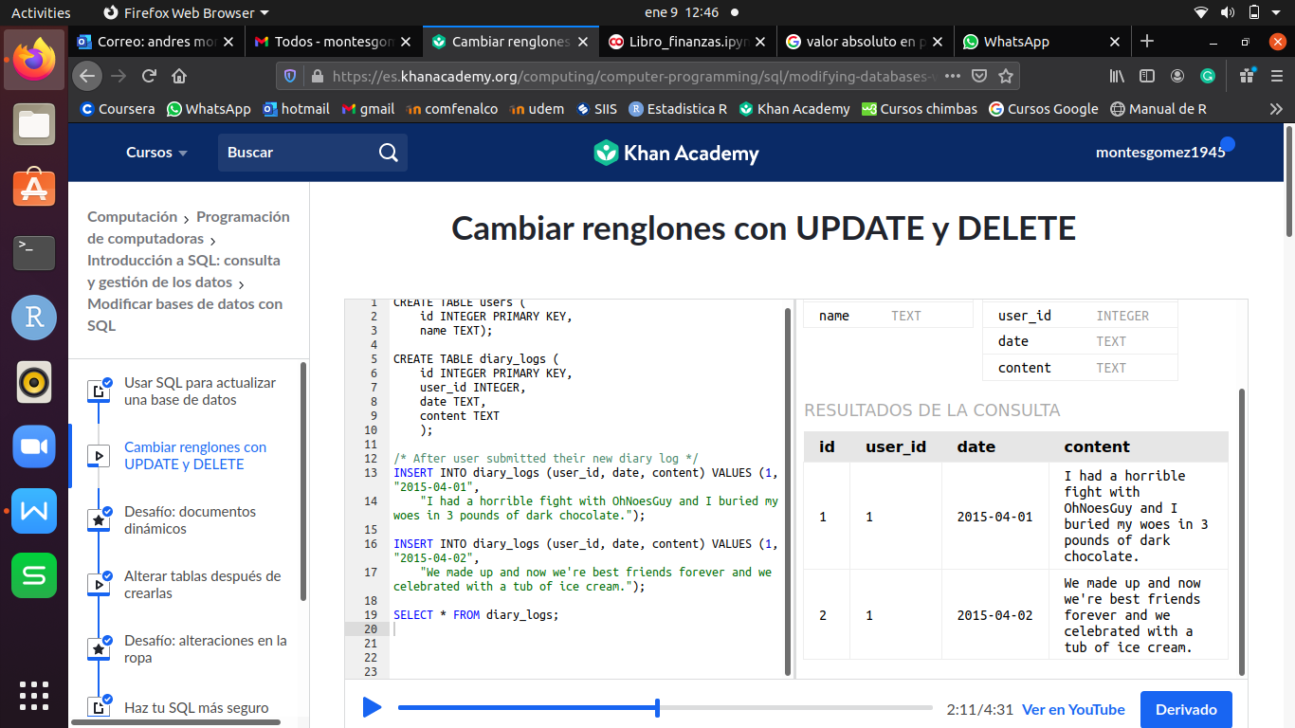

UPDATE diary_logs SET content = "I had a horrible fight with OhNoesGuy" WHERE user_id=1 AND date = "2015-04-01";

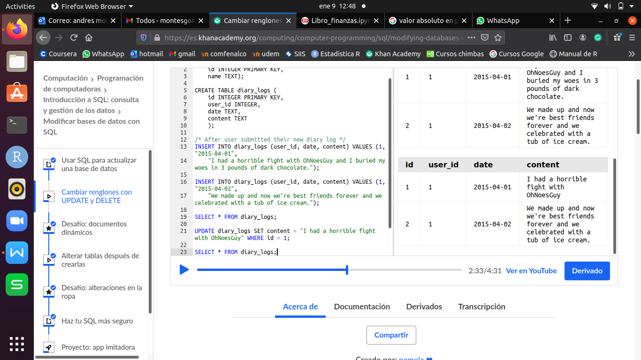

1. **DELETE**

DELETE FROM table WHERE id(PK) = # ó filtrando;

**EXAMPLE:**

DELETE FROM diary_logs WHERE id = 1;

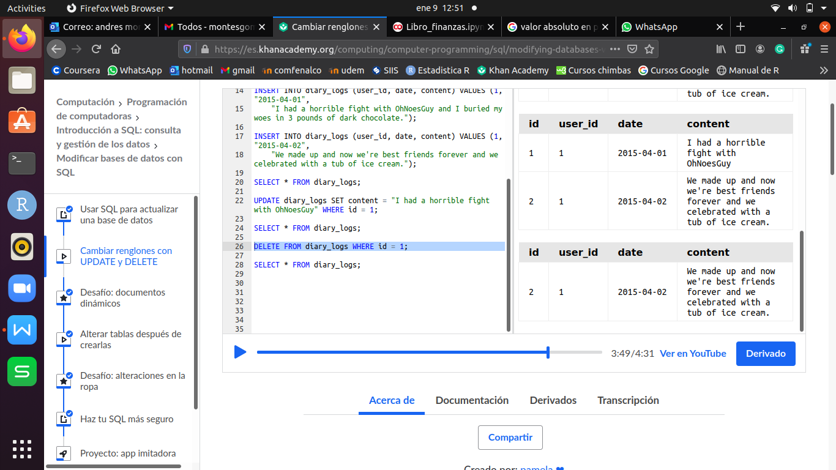

1. **ADD A NEW COLUMN (ALTER TABLE)**

ALTER TABLE tabla ADD nom_col TIPO default ‘new content’;

**EXAMPLE:**

ALTER TABLE diary_logs ADD emotion TEXT default "unknown";

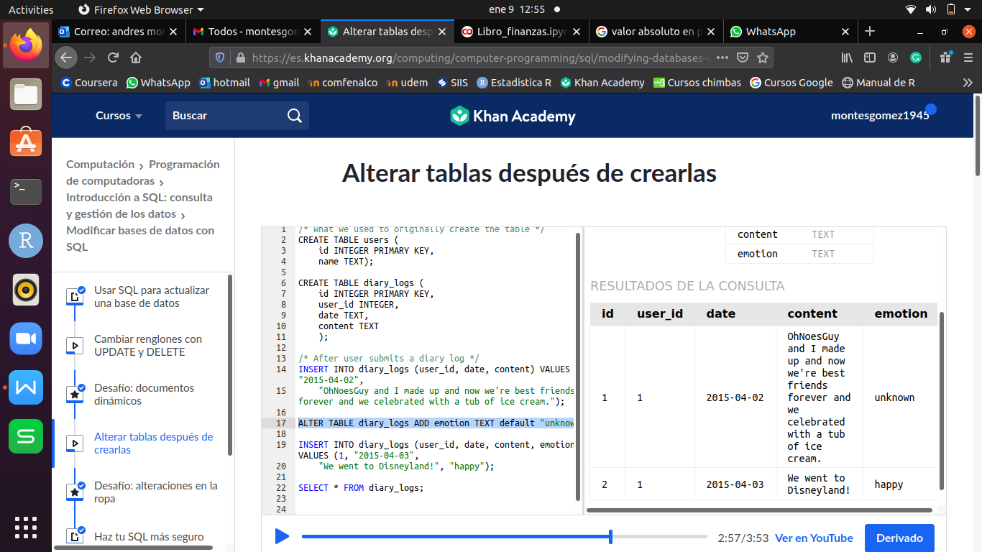

1. **DELETE TABLE (DROP TABLE)**

DROP TABLE tabla;